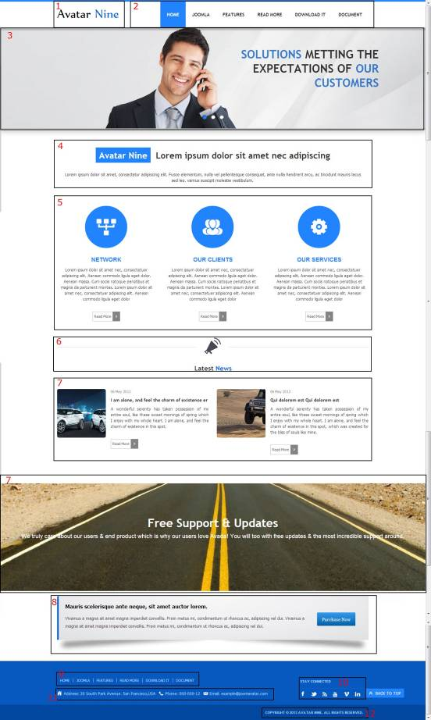

All of our templates are packed with:
- Extensions - These are modules/plugins/component to use on this template.
- Template - This is only the template install file
- Quickstart - This is your main quickstart package, it will help you to rebuild demo.
- Documentation
If this template is not downloaded directly from amazing-templates.com. Please, go to our website and download full template pakage.
This documentation file helps you build your site manualy
1.
Module Type: Custom HTML
Module Name: Logo (hide title)
Module Class Suffix: no-padding-marging avatar-template-logo
Position: Top-left
HTML source code:
<p><a href="Your Link Site "><span style="color: #000;">Your</span> Site Name</a></p>

2.
Module Type: Menu
Module Name: Main Menu
Module class suffix: _menu no-padding-marging
Menu class suffix: avatar-main-menu
Alternative layout: Responsive
Position: Top-right

3.
Module Type: Avatar Articles Nivo
Module Name: Banner Tool Home
Module Class Suffix: avatar-caption no-padding-marging avatar-banner-full
Module Postion: Tool (width of TOOL BLOCK is 100% (configuration in templates manager))

DATA
Go to Content Manager.
Creat New Category.
Create articles in category just created.
In a newly created articles, Select intro image and written content slide.
Then go to the Banner Tool Home Manager.
Select the category for slidershow.

4.
Module Type: Custom HTML
Module Name: Slogan-home-new-style-1
Module class suffix: no-padding-margin-side
Position: Content-top

HTML source code:
<p class="avatar-slogan-3" style="text-align: center;"><span class="avatar-char-color">Avatar Nine</span> &nbsp;Lorem ipsum dolor sit amet nec adipiscing</p>

5.
Module Type: Avatar Template Showcase
Module Name: Features - Home News Style 3
Module class suffix: no-padding-margin-side
Module showcase: features_2
Position: content-top

DATA
Go to Content Manager.
Creat "ABOUT US" Category.
Create articles in category just created.
In a newly created articles, and add image icon like demo.
Then go to the Features Home News Style 3 Manager.
Select the category for display.

6.
Module Type: Custom HTML
Module Name: Latest News title - Home new style 3
Module class suffix: no-padding-margin-side
Position: content-top
HTML source code:
<div style="padding: 15px 0; border-top: solid 1px #d9d9d9;">
<p style="font-family: mainfont; text-align: center; font-size: 20px;"><img style="margin-top: -70px; background-color: white; padding: 25px;" src="images/sampledata/avatar_nine/last-news-icon.PNG" alt="" /></p>
<p style="font-family: mainfont; text-align: center; font-size: 20px;">Latest <span class="avatar_text_color">News</span></p>
</div>

7.
Module Type: Avatar Template Showcase
Module Name: Lastest News - Home New Style 3
Module class suffix: no-padding-margin-side
Module showcase: NEWS
Position: content-top

DATA
Go to Content Manager.
Creat "Extensions" Category.
Create articles in category just created.
In a newly created articles, and add article image.
Then go to the Features Home News Style 3 Manager.
Select the category for display.

7.
Module Type: Custom HTML
Module Name: Free Support & Updates
Module class suffix: avatar-bg-road no-padding-marging
Position: full-5
HTML source code:
<h1 style="text-align: center;">Free Support &amp; Updates</h1>
<p style="text-align: center; font-size: 18px;">We truly care about our users &amp; end product which is why our users love Avada! You will too with free updates &amp; the most incredible support around.</p>

8.
Module Type: Custom HTML
Module Name: Slogan bottom - home new style 3
Module class suffix: avatar-slogan no-padding-margin-side avatar-shadow-1
Position: full-6
HTML source code:
<p style="float: right; margin: 30px 20px;"><a class="btn" href="#" target="_blank"><span style="font-size: 13px; line-height: 24px;">Purchase Now</span></a></p>
<p><strong style="line-height: 24px; font-size: 16px; color: black;">Mauris scelerisque ante neque, sit amet auctor lorem. </strong></p>
<p><span style="line-height: 24px; font-size: 13px;">Vivamus a magna sit amet magna imperdiet convallis. Proin metus mi, condimentum ut rhoncus ac, adipiscing vel dui. </span><span style="font-size: 13px; line-height: 24px;">Vivamus a magna sit amet magna imperdiet convallis. Proin metus mi, condimentum ut rhoncus ac, adipiscing vel dui.</span><span style="font-size: 13px; line-height: 24px;"><br /></span></p>

9.
Module Type: Menu
Module Name: Footer Menu
Module class suffix: no-padding-margin-side
Menu class suffix: avatar-footer-nav
Alternative layout: Responsive
Position: Footer-Left

10.
Module Type: Custom HTML
Module Name: Address
Module Class Suffix: avatar-module-border-top avatar-footer-address no-padding-marging
Position: Footer -left

HTML source code:
<ul style="display: table;">
<li class="avatar-address"><span style="line-height: 1.3em;">Address: Your Address</span></li>
<li class="avatar-phone"><span style="line-height: 1.3em;">Phone: Your Phone Number</span></li>
<li class="avatar-email"><span style="line-height: 1.3em;">Email: Your email</span></li>
</ul>

11.
Module Type: Custom HTML
Module Name: STAY CONNECTED
Module Class Suffix: no-padding-margin-side social-heading
Position: Footer -right
HTML source code:
<div class="avatar-footer-social avatar-module-border-top">
<a class="facebook" href="Your Facebook Link"> </a>
<a class="twitter" href="Your Twitter Link"> </a>
<a class="feed" href="Your Feed Link"> </a>
<a class="youtube" href="Your Youtube Link"> </a>
<a class="vimeo" href="Your Vimeo Link"> </a>
<a class="linkedin" href="Your Linkedin Link"> </a>
</div>

12.
Module Type: Custom HTML
Module Name: copyright
Module Class Suffix: avatar-copyright
Position: Footer

HTML source code:
<p><a href="www.joomavatar.com">Copyright © 2013 Avatar Nine. All Rights Reserved.</a></p>

